INCOME INIQUALITY IN DENMARK AND USA
Name
Institutional Affiliation
Date

INCOME INEQUALITY IN DENMARK AND USA
There is much concern in the Danish society about the matters that are related to the income inequalities and the growth of the economy. Denmark has been marked among one of the least unequal countries across the globe. The recovery from the financial crisis has been sluggish, and the GDP of the country has been below the pre-crisis level. It is predicted that the Danish economy is to grow below the 2% in the near coming years though some of the prospects are uncertain. In the past, the GDP and the growth have benefitted the household fairly with equality in the mid-1980s to mid-2000s. The retributive feature of the income of the Denmark has been weakening from the recent years (Osler et al 2002).
This puts Denmark among the lowest degrees of the income inequalities. Income inequality in Denmark has been increasing, and there are some of the factors that are triggering this particular kind of a move. The income inequality in the Denmark has grown from the past 30 years; the step is linked to the significant number of the students and the society youths that are paid less. The primary factor that seems to boost the level of remedy on the issue of inequality is the education for both men and \the women in the society. Additionally, the effect of the modern family formation has been termed as the driver for the inequality. There are some of the evil activities that have been linked to this income disparity in the society. This includes the high level of the crime rates and increases level of poverty. The recent increase in the profoundly linked to the changes in the system of taxation.

Household Inequality
The disposable household income falls within the niche of the most equal; in the world. As per the OECD the coefficient of the Gini 0.23 in the year 2000 and the distribution has changed to the positive due to the well-structured system of the tax transfer.
As per the recent analysis that is majorly based on the series for all OECD countries indicates that the reforms that were put forward in the recent years increased the level of inequality in the household sector. This marks the case of the reduced level of income inequalities in the Denmark (Osler et al 2002).
Individual income inequality
The possibility of the cause of the rising inequality leans much on the demographic differences, the level of the education and the changes in the system of taxation.

Demographic changes
This is mainly divided into two primary groups: The active and the passive age group. The main division that will give a clear analysis of these two group is the division of age below and above 65. Those who are below the age of 65 falls within the active and those above are the passive citizens. The two groups marks the direction of the economic status in Denmark as there are many passive than active members in the society.

Demographic Composition of Denmark Population

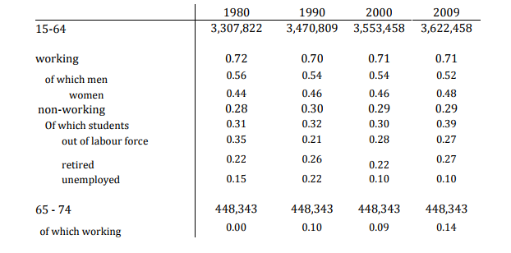

Income inequality in the U.S.
Income inequality has been something of great concern, and it has impacted the Americans from the time the American Dream was conceived. This dream was and is still aligned with the idea of hard work to ensure an increase in economic growth. It is unfortunate that this vision is unattainable because of the low income and the uneven distribution of wealth as well as revenue among different social classes. This has led to the rise in inequality since the poor become poorer while the rich continue being wealthier. This increases the uneven differences between these two social classes.
The central causes of the increasing gap in the income inequality are not majorly political, but economic and technological factors. They comprise the market factors, transfer policies, taxes and many other causes. Automation has eradicated many jobs which Americans have from the ancient times depended. Additionally, Technology has caused many nations including the United States to open companies outside the country. This is referred to as globalization. This not only deprives the government tax, but it also results in joblessness. Government policy is another factor causing the widening gap in income inequality in the U.S. The government can lower or raise personal tax which in turn affects investment and the economic growth (Piketty, 1997).
There is no one method which can be used to reduce the increasing income inequality. Thomas Piketty in his book portrays a disturbing image of civilizations which only a few dominate and their aggregate wealth and earnings surpass the majority who depend on income (Piketty, 1997). To reduce this widening gap, the government must step in and take some measures, for instance, investing in education, unionizing of low-wage employees, investing the country's infrastructure, and giving a share in the future economic gains to all the Americans. Doing so would reduce the income inequality in America. Otherwise, the living standards of the poor will continue worsening while the richer continue being richer.

References
Piketty, T. (1997). The dynamics of the wealth distribution and the interest rate with credit rationing. The Review of Economic Studies, 64(2), 173-189.
Osler, M., Prescott, E., Gr, M., Christensen, U., Due, P., & Engholm, G. (2002). Income inequality, individual income, and mortality in Danish adults: analysis of pooled data from two cohort studies. Bmj, 324(7328), 13.

